Name: Class:
Introduction
In order to investigate the relative reductant strength of metals, a series of electrochemical cells may be used. One such cell (cell 1) is shown below. All solutions used are 1.0 mol L^{–1}.

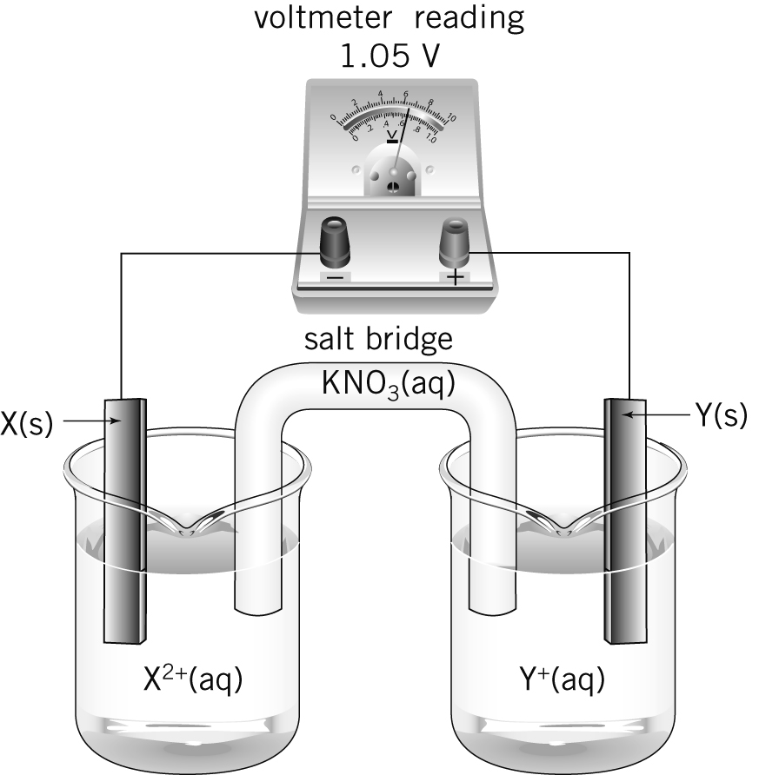

No. | Question | Answer
For the cell shown above:
a which electrode (X or Y) is positive?
b in which direction are the electrons flowing?
c which electrode (X or Y) is the anode?
d in which direction are anions flowing through the salt bridge?
For the cell shown above, write balanced half-equations for the reactions occurring at:
a electrode X
b electrode Y.

A second cell (cell 2) was set up. A strip of metal, Z, was placed in a beaker containing a
1.0 mol L^{–1} solution of Z(NO₃)₂. This half-cell was connected to the X²⁺/X half-cell used in cell 1. Electrons flowed from electrode X to electrode Z, and a cell potential of 0.59 V was recorded.

For this cell, write balanced half-equations for the reactions occurring at:
a electrode X
b electrode Z.
Based on the observations made in questions 1–3, list the metals X, Y and Z in order of decreasing reductant strength. Explain how you arrived at your order.
For a cell constructed by connecting the Z²⁺/Z and Y⁺/Y half-cells, predict the following:
a the direction of electron flow
b the anode
c the reduction half-equation
d the cell potential.
If the set of half-cells used above was constructed using 0.5 mol L^{–1} solutions and the experiment was repeated, what changes in results, if any, would you expect?
All half-cells in this series of cells have been connected using filter papers dipped in potassium nitrate solution. Explain why potassium nitrate is a suitable substance to use in this way.
If metal Z is identified as copper, suggest a possible identity for:
a metal X
b metal Y.

